Hello, Sir

I am working on build and run of trains now. By the way, I have many questions because I don’t know well about the train business. To avoid the confusion, I write the questions here.

1. **Aim of this application**

I saw the photos on railway model board including some train models, station models and roads you sent some months ago.

So, our application(trackboss) will control the train models remotely in this railway model board?

For the more, if this application is complete in the test, this application will control the real trains remotely by using some communication method?

There are no plans to control real trains. The communication method will be used later for network setup for remote connections, etc. “Communications” has nothing to do with building trains.

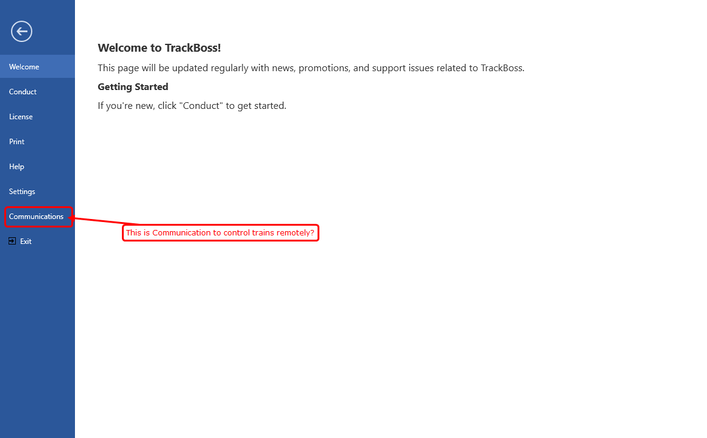

1. **WorkFlow of this application.**

In order to build&run the trains,

* crew, locomotive, caboose, cars should be ready in the original station.
* Road should be ready(including all stations on the way)

This is correct? Or need more? What means workpaper?

Caboose, Cars, locomotives need to be in locations, yes. Please note, only the cars are truly essential.

Paperwork is an actual physical printed copy of the work of the train. It is called a “manifest” or “switchlist”.

Lets suppose a train has been built and run.

Then, this train would be back to the original station for next build and run without another work(service schedule)?

Or this train would work on another schedule from destination?

Each train is independent, UNLESS we have built a connection. Again, I strongly suggest successfully building a simple train between two cities with 3 cities in between just to see if you can get a train to pick up and set out cars appropriately along the way.

1. **About the functions of elements in Service module related to OPS**
2. **Characteristics**

It’s okay now.

1. **Routing**

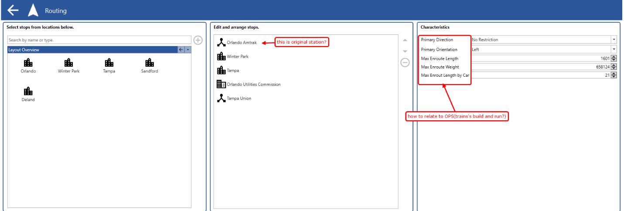

These options will be related to assign locomotive, cars to train?

I hope you explain about this part in detail.

In the above example, the origin is Orlando Amtrak. The characteristics to the right, we will cover later. However, these are physicial characteristics of the train. For instance, if max train length = 20, then the train cannot exceed 20 cars along the route.

For instance, if a train goes from City A to City D, with stop in City B and City C. That train should not exceed 20 cars.

Leaves City A with 6 cars.

At City B is has 2 cars to set out. Therefore, it cannot pick up more than 16 cars.

6-2 =4

20-4 = 16

But of course, there are other factors in train characteristics that might limit the train already to only pick up 3 cars maximum in City B.

Consider these characteristics as “maximum” allowed.

1. **CarType**

OPS will select cars belong the checked cartype.

1. **Crew Printing**

I am not sure about this sub module.

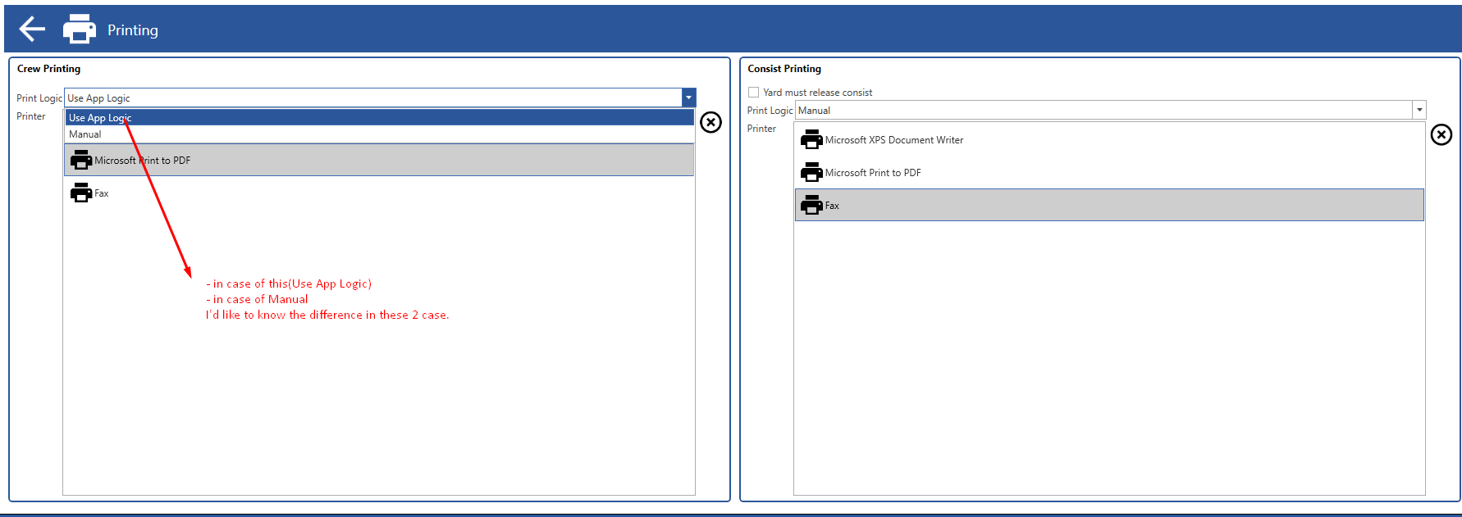

* Difference between “Use App Logic” and “Manual”?
* Difference between “Microsoft XPS Document Writer” and “Microsoft print to PDF” and “Fax”
* “Yard must release consist” is checked and not: how is this related to OPS?

Use “app logic” means the program is deciding where to print the consist to. You will learn later that it might send as a text to a smart phone or tablet. It also is using the preferences of the individual crew member that is assigned to that train.

Under manual, that is a list of available printers, when I created that, there were not printers connected to the network.

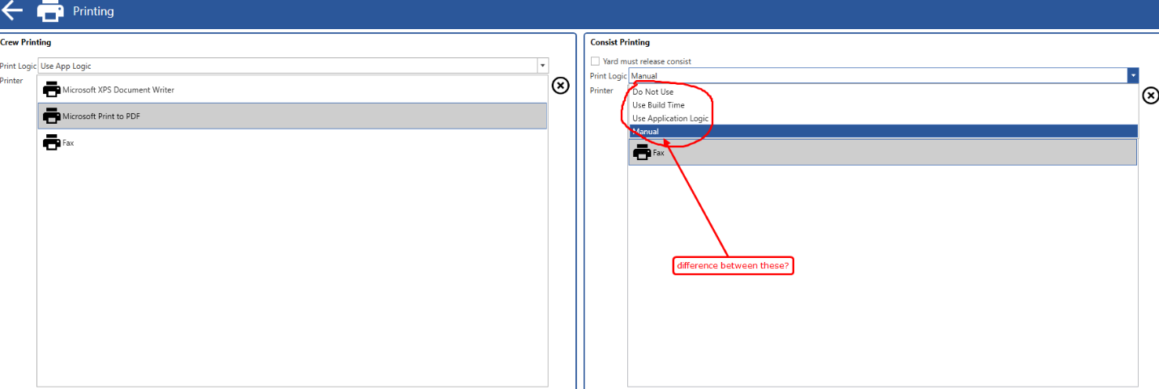

* Difference between “Do not Use” and “Use Build Time” and “Use Application Logic” and “Manual”

If Print Logic = Automatic (or something similar)

“do Not use” means do not print a consist because the crew will use what was generated by the yard.

“use Build time” means that when the build time on ops is reached, then the consist will print at that build time.

“use application logic” means that the consist will print at the appropriate time when a crew has been assigned to the train and other logic functions that will be more apparent later. In short, it is model railroad AI.

I’d like to know how these options are related to OPS.

1. **Build Source**

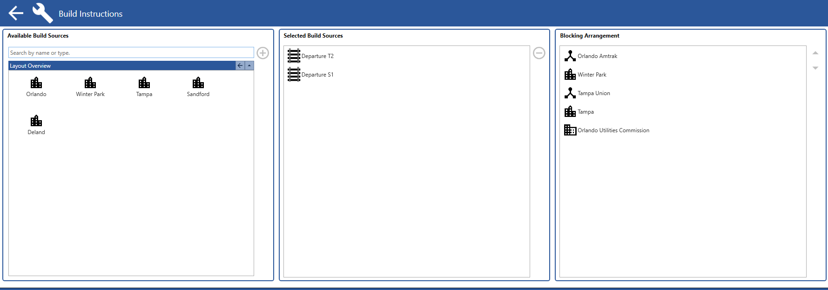

* What is this sub module? How is this related to OPS?

The left box, Layout Overview, is a list of the cities on the railroad.

Build Sources are the selected specific cities, industries or tracks for which Trackboss can find appropriate cars to use in the CITY OF ORIGIN.

For example, let’s say that in the above example, the first city is WINTER PARK. Winter park has a yard with 6 tracks. They are labeled and identified as follows:

Track 51

Track 52

Track 53

Track 54

Track 55

Track 56

In the middle box, “selected build resources”, we selected Track 52 and Track 55. That means Trackboss is limited to only selecting from those two tracks to pick cars to go into the train.

***This particular module was not completed before and so will need some work.

The right most box is the “blocking order”. One should be able to move individual lines up and down in that list. A blocking order is when you put all cars destined for one place together on the list. In the example above, all of the cars bound for city of Tampa would be together..and on the list of building the train, all the cars, regardless of what track they came from would be shown together that were bound for Tampa. Again, has to do with how the train starts out. The user should be able to move those individual listings up and down.

1. **Crew Instruction**

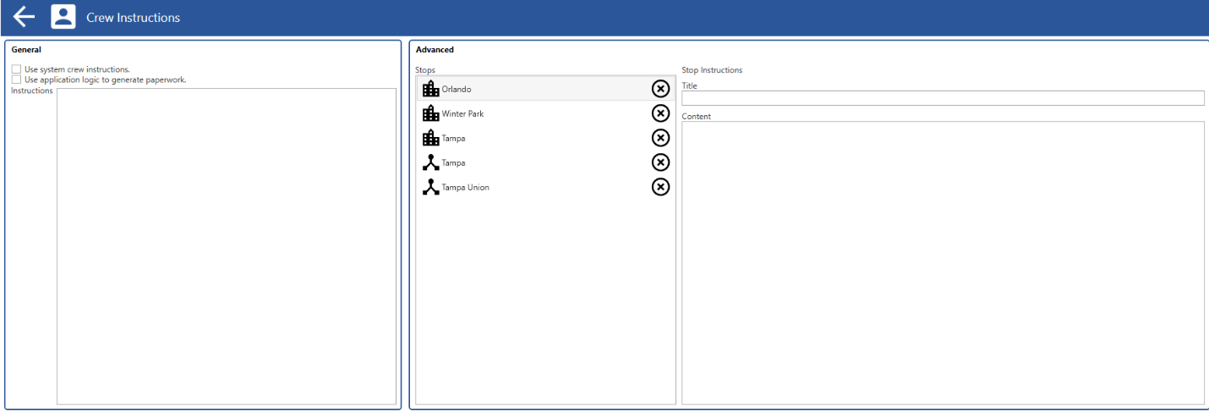

* What is this submodule?
* What is “System Crew Instruction”? If this option is checked, how to affect to OPS?
* What is paperwork? If this is checked, how to affect to OPS?
* How is stops(Advanced) related to OPS?

Great questions, by the way. Shows you are truly paying attention.

Okay, on our printed consists (i.e. paperwork), crews will have a list of work to do in each city. There will be times when a specific train might have unique instructions in a particular city that will have importance to the crew operating that train. In the above example, on the consist/manifest/switchlist for this train, there would be special instructions on the printed list at the stop in Tampa. It might say in Title: “Autorack Handling”. In content, it might say “place all even numbered cars on the north end of the ramp and all odd numbered cars on the south end of the ramp”.

“System Crew Instructions” is generated elsewhere. Selecting that box means that particular set of instructions prints on every mainline/extra consist manifest.

1. **Locomotive Logic**

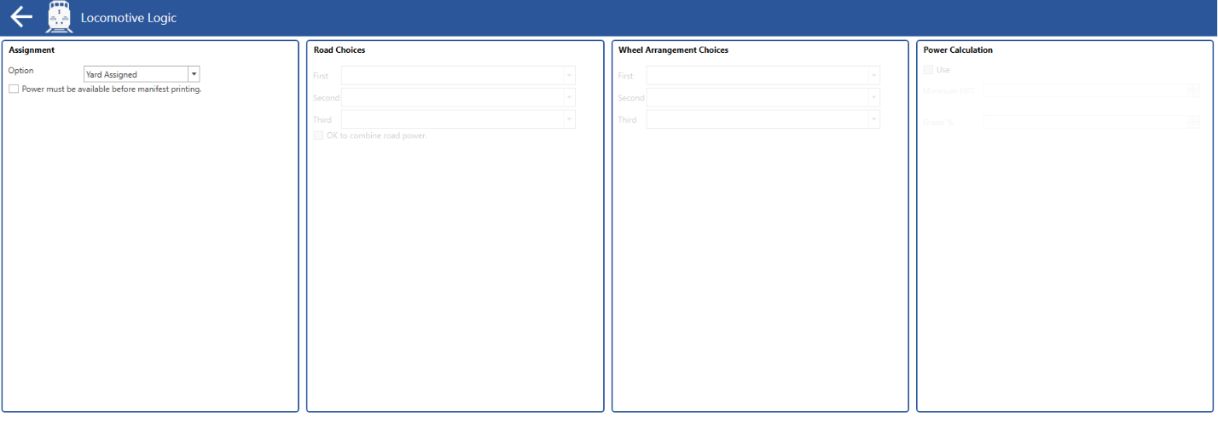

* If “Yard Assigned” is selected, how to assign locomotive to train?
* What is “manifest printing”?

Yard Assigned is really meant for a yard crew to manually select the locomotive(s) and be able to input that info via a remote desktop or TrackBoss App on their smart phone or tablet.

Manifest printing is the consist/switchlist/paperwork that the mainline or extra crew uses. I apologize for using those words interchangeably.

1. **Caboose Logic**

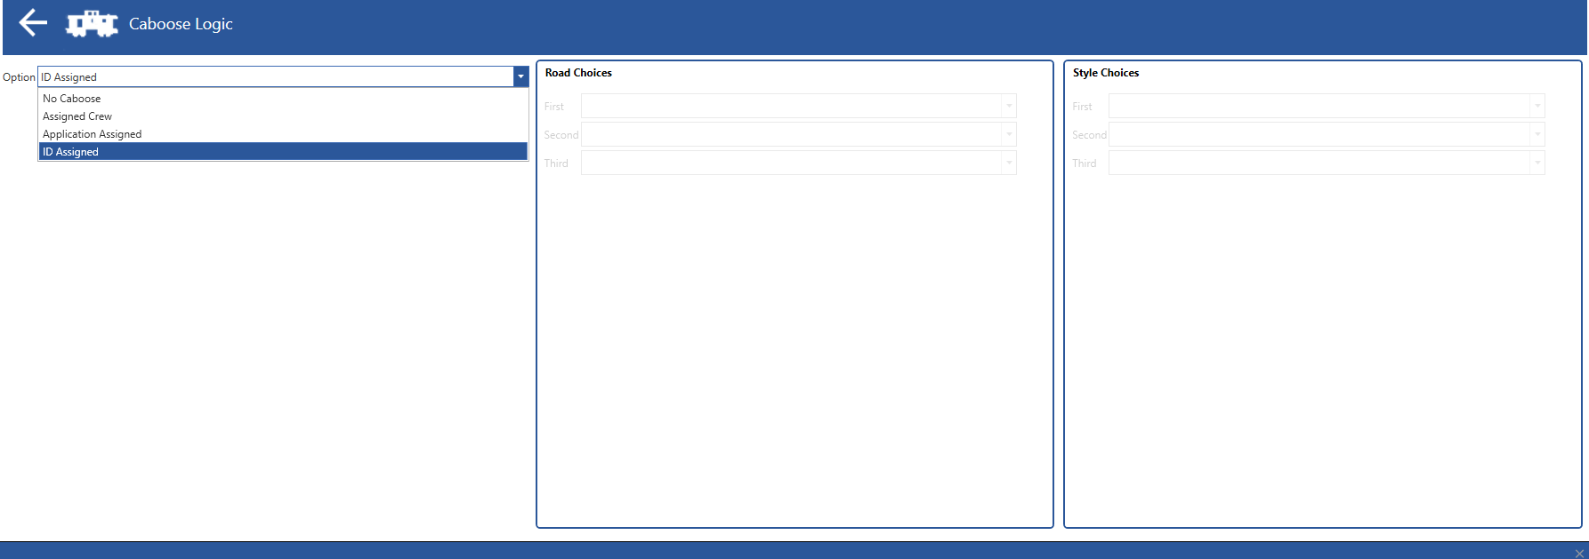

* If “No Caboose” is selected, train will be built and run without Caboose? CORRECT
* If “Assigned Crew” and “ID Assigned” is selected, how to assign Caboose to train? Remove Assigned crew and ID assigned for now. We’ll come back to that later.

1. **Application Logic**

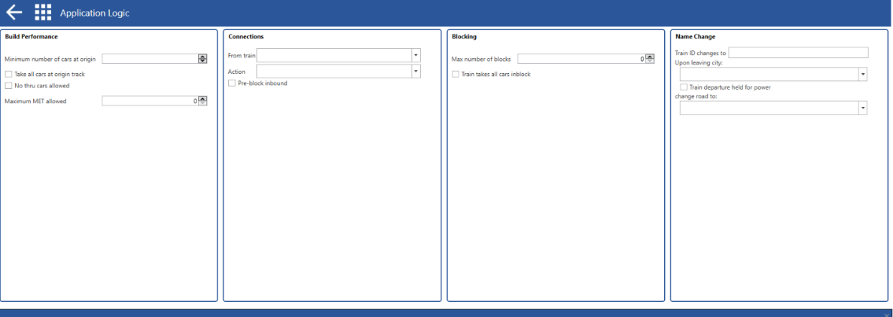

* Difference between if “Take all cars at origin track” is checked or not?

This check box is used to tell Trackboss to overrule any limits on train length, delay time etc only at the origin and take every car on the track.

* Difference between if “No thru cars allowed” is checked or not? “no thru cars allowed means that when the train is built at the origin, none of the cars in the consist (i.e. train) are allowed to go all the way to the last stop.

What is “Maximum MET allowed”? This is a formula pulled from the city side. Maximum Effective Trainwork is what is stands for.

* If “From train” is selected, how is this related to OPS(build and run of train)?

This will be one of the more challenging things to work on. It essentially says that the train being built now, must be a continuation from a prior train. I will try to do my best to explain.

Train 132 runs a route from Orlando to Tampa. It then is terminated (i.e. completes the work). On a model railroad, train consists are often reused to keep going as the next train in a series. In our example, train 145 may come back out on the railroad from Tampa to Orlando, BUT it will use the consist (cars and maybe even loco and caboose) from train 132. So 145 cannot be built until it is at least known what 132 will look like upon termination.

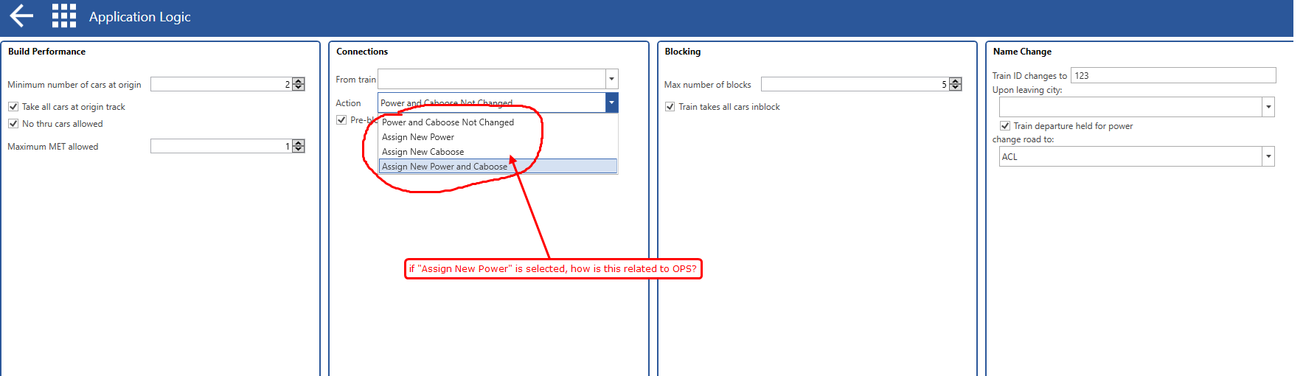

* If “Assign New Power” is selected, how do this affect to “build and run” of train in OPS?

Again, using our example above, train 145 would get new power (power = locomotives/engines) put on the cars and caboose from train 132.

* Difference between if “Pre-block inbound” is checked or not?

Again, a challenge. “pre-block inbound” says that train 132 car list at the last stop in Tampa will reflect the blocking order for 145.

* What is block?

A block is a group of cars going to the same destination along the route.

* Difference between if “Train takes all cars inblock” is checked or not? I have no idea why that is there at this point.
* If “Train ID changes to” has value, when would this Train ID be changed?

Okay, if the train ID changes, it means a train goes from being train ZWILTAC from Orlando to Tampa, but it leaves Tampa as train IWILSHV, but it is all on the same printed consist. It is just changing how the train is named.

* What is “Upon leaving city”? That is specific location on which the name change occurs.
* Difference between if “Train departure held for power” is checked or not? This is where a “hold” is placed on “run time” on ops. Think of it as a delay. The reason is because if the appropriate assigned power is not present, Trackboss will not “release” the train to a crew until the appropriate power has arrived AND able to be sent out.
* If “change road to” has value, when would this Road be changed? At the same location as listed in “upon leaving city”.

If Road is changed before this train begin to run, it’s to rebuild this train from scratch, I think

By definition, it cannot be changed at the city of origin or the final city. Would only be able to do so in an intermediate stop along the route.

1. **Extra Board Logic**

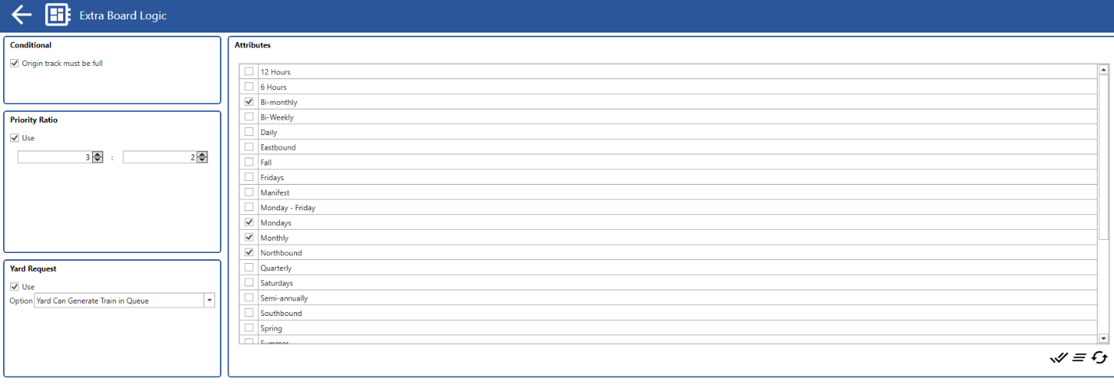

* Difference between if “Origin track must be full” is checked or not?

If checked, the extra train will only build when track is at max capacity.

* How do this affect to “build and run” of train in OPS? See above
* What is “Priority Ratio”?(there are 2 value fields) Can simplify, but basically saying how often TrackBoss should try to generate this particular extra board train. The higher the ratio, the more likely that particular train will be looked at to be built and run.
* Difference between if “Yard Can Generate Train in Queue” is selected or “Run Only with Yard Request” is selected?

“Yard can generate train in queue” This is when the yard can control and influence the generation of a extra board train via an app or desktop connection. Trackboss can still generate the train automatically through its own algorithm, but this would be thought of as a “yard override” feature.

“Run only with yard Request” is the only time that particular train can be built/run is if the yard so chooses.

* What is “Attributes” here? Most likely unnecessary here.  
  There are “Attributes” in Characteristics sub module, btw…? Duplication and not necessary.

1. **Division Point Logic**

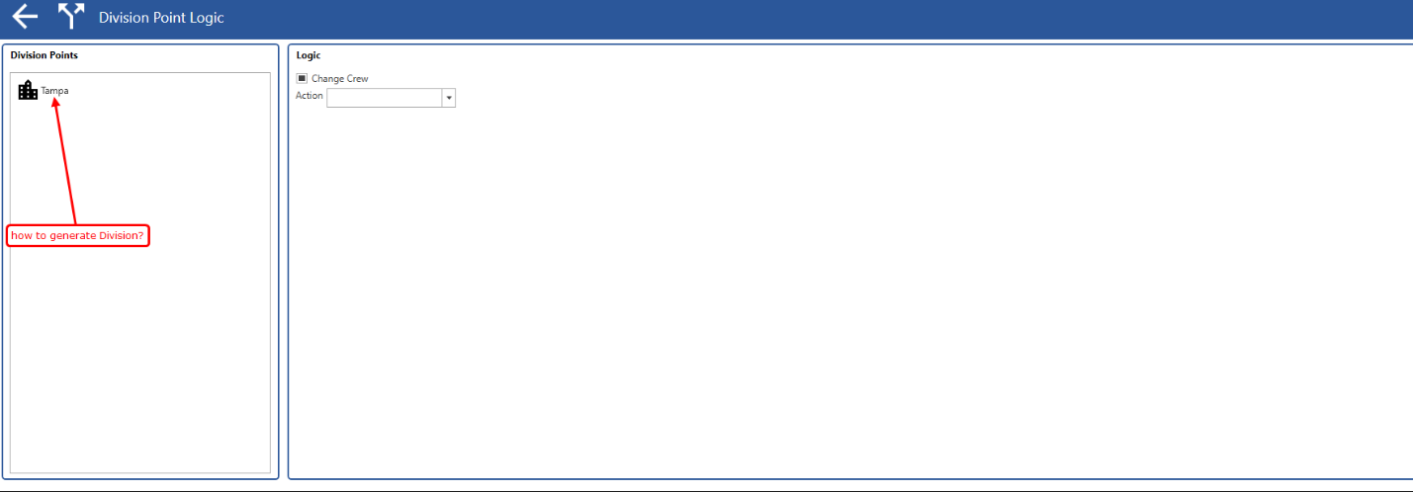

* How to generate this Division? Should be a check box in the city under city module designating a “division point”.
* If Crew and Power(Caboose) should be changed, it should user consider this when assign Crew, Power, Caboose in OPS… right?
* This should still have automated option through trackboss as in other trains.

1. **Work Edit**

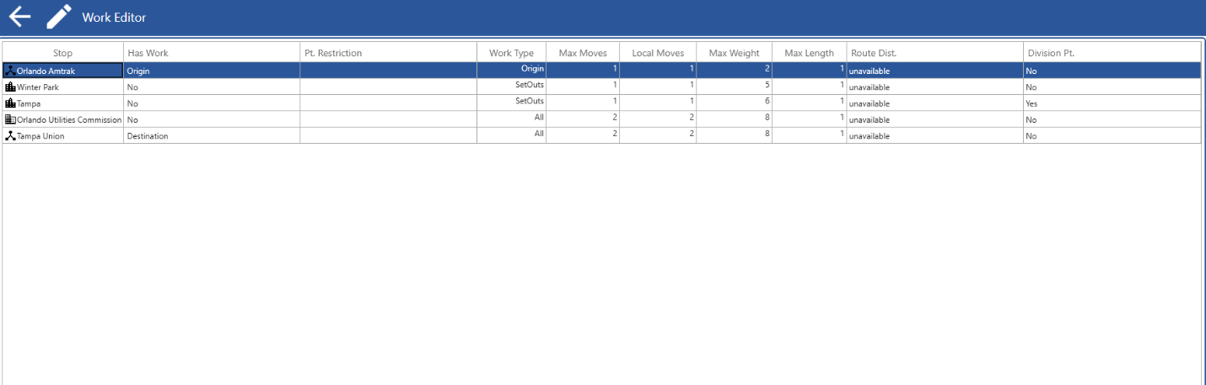

* How is this sub module related to OPS?

Okay. Important screen.

Stop = a point along the route, either the origin, a point in between (in the order shown on the screen), and the destination.

Has Work = Origin and destination are automatic. Nothing can really change about those. In the above example, Winter Park, Tampa and Orlando Utilities commission are all intermediate stops and can or cannot have work. (yes is default)

Pt Restriction = either “trailing” or “facing” (or blank and blank is default). This says the work in that town is restricted to only trailing point or facing point moves. Will explain later, but is linked to direction of train and direction of spur.

Work type = “all” is default, “set outs only” is that cars in this train at this stop can only be set out and nothing picked up. Pick ups only is that the train can only pick up cars from tracks in that stop/location and no setouts.

Max Moves = “5” is default. Max moves is short for maximum moves. This includes the sum of pick ups and set outs. For instance, if set to “5”, the train can only do a maximum of 5 car moves in that location. It could be 3 set outs and 2 pick ups (=5). It could be 4 set outs and 1 pick up (again, =5)

As result, I think I need to have lesson about workflow on build and run of trains because we have not requirement.

About 30 hours.

Then, we can complete this project asap.

I know you are very busy for your business. But, it’s difficult to complete this project without your help.

I hope you take the time for the lecture.

Sincerely.